**Table of Contents**

Document Control Information 3

Approval 3

Glossary of Terms 3

Abbreviations 3

Definitions 3

1 Introduction 4

2 Business Requirements 4

3 High-Level Design 4

3.1 System Architecture 4

4 Functional Requirements 4

4.1 List of functions 4

4.2 Use Cases 5

5 Non-Functional Requirements 5

5.1 Transaction Volume 5

5.2 Performance Requirements 5

5.3 Security Requirements 5

5.4 Software Quality Attributes 6

5.5 History Requirements 6

5.6 Archiving Requirements 6

5.7 Frequency 6

5.8 Dependencies 6

5.9 Access Rights (Roles and Profiles) 6

6 Other Requirements 6

7 Functional Design Considerations 6

8 Interface Requirements 7

8.1 Interface Data Structure 7

8.2 User Interfaces 7

8.3 Hardware Interfaces 7

8.4 Software Interfaces 8

8.5 Communications Interfaces 8

8.6 Module Interfaces 8

9 Configuration Changes 8

<Define any other configuration changes that must be applied for this change> 8

10 Testing Requirements 8

10.1 Test Scenarios 8

11 Documents to be updated 8

12 References 9

12.1 Reference Documentation (include reference to test pack) 9

13 Functional Specification Signoff 9

**Introduction**

Eskom have been tasked to create a service for South Africa, the service is to provide detail, of which Government, Eskom would through planning create schedules with a Region Zone Area breakdown. Distribution of schedules for Not already on Contract or Agreement, extending to Municipalities, by online facility or per envelope to Community Leadership,

schedules per Industrial, Residential occupants Day, Week, Month.

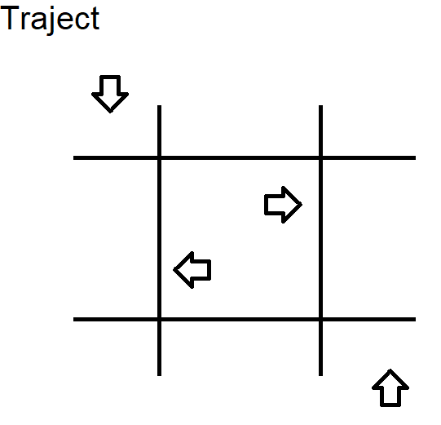

Detail for the Youth of South Africa, and their respective Parents, to do their part at Home, Work and Sport. Team effort having decided the Industry, Profession Business, Budget their energy, volume production, services expansion. Turning resources into profit sharing of which the strong would Lead, Large enough money could even bid on Power at Meter.

**Business Requirements**

Representatives selling, when setting price, formulate and adjust to market conditions, stimulus and inputs. Customers vet adjusting budget, compare price, volume.

**Detail**

z.) Overview simplified our Largest Systems, have a FIN-HR-MM core, with applications used daily of which the host(s). (EDCON, Eskom, Water)

y.) Firma’s and Companies have Products Services for sale, Plants, Factories rail and transport to Bays Depots and Warehouses. MM-HR-FIN.

x.)Individuals trade (Tax Types) Selling or Buying in hand App, or Terminal application, point-of-sale

d.) Requirement for detail List of each. (Value, Quantity, Hour) Treasury set a target that focus on Category for Services Items be made.

**Technical**

Mandatory fields when reports are created, require specification. The Public to compare Slips, Receipts, Invoice. for source of List detail.

(buff)

**High-Level Design**

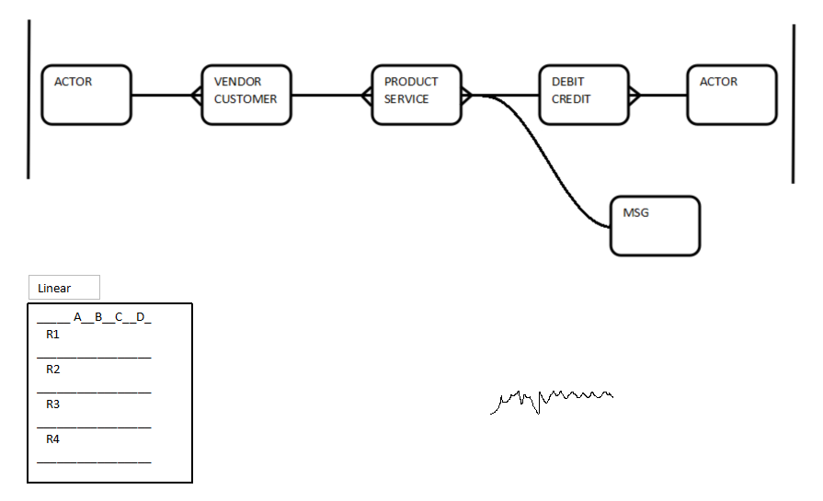

**Functional Requirements**

T: Band determine buffer, of which proc, hook procces set.

B: Line | Line direction proceeds of legal tender, indicate direction of sold service, item

Irrespective thereof, Functional Requirements include Technically how to obtain valid Digital Line to reflect per List. Band authority apply (a) from device, (b) from host.

**Non-Functional Requirements**

Pairing line (a) | line (b).

**Extended Requirements**